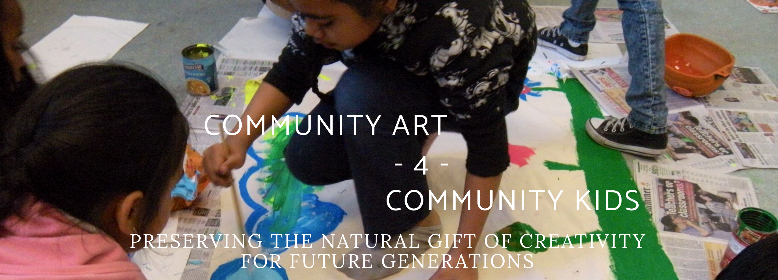
Art Rocks Club House Project Proposal

Date:
Phone Number: Email:

Name or Organization Name:

Proposed Project Name:

How does your project align with our mission statement?

company name
Our projects are site specific in San Francisco’s Hunters Point District. We fund projects that foster creativity & communication

Project Description:

Project Budget :
Description |  |  | Cost
expenses
materials needed
artists / teachers / instructors fee |  | \
miscellaneous
Total |  |  | $‎ 0

